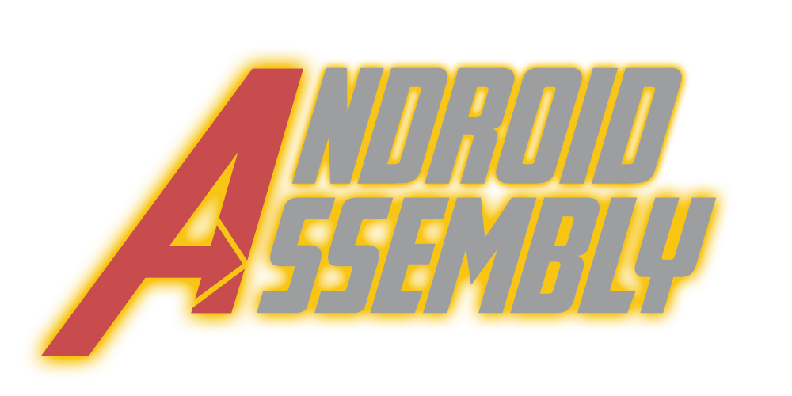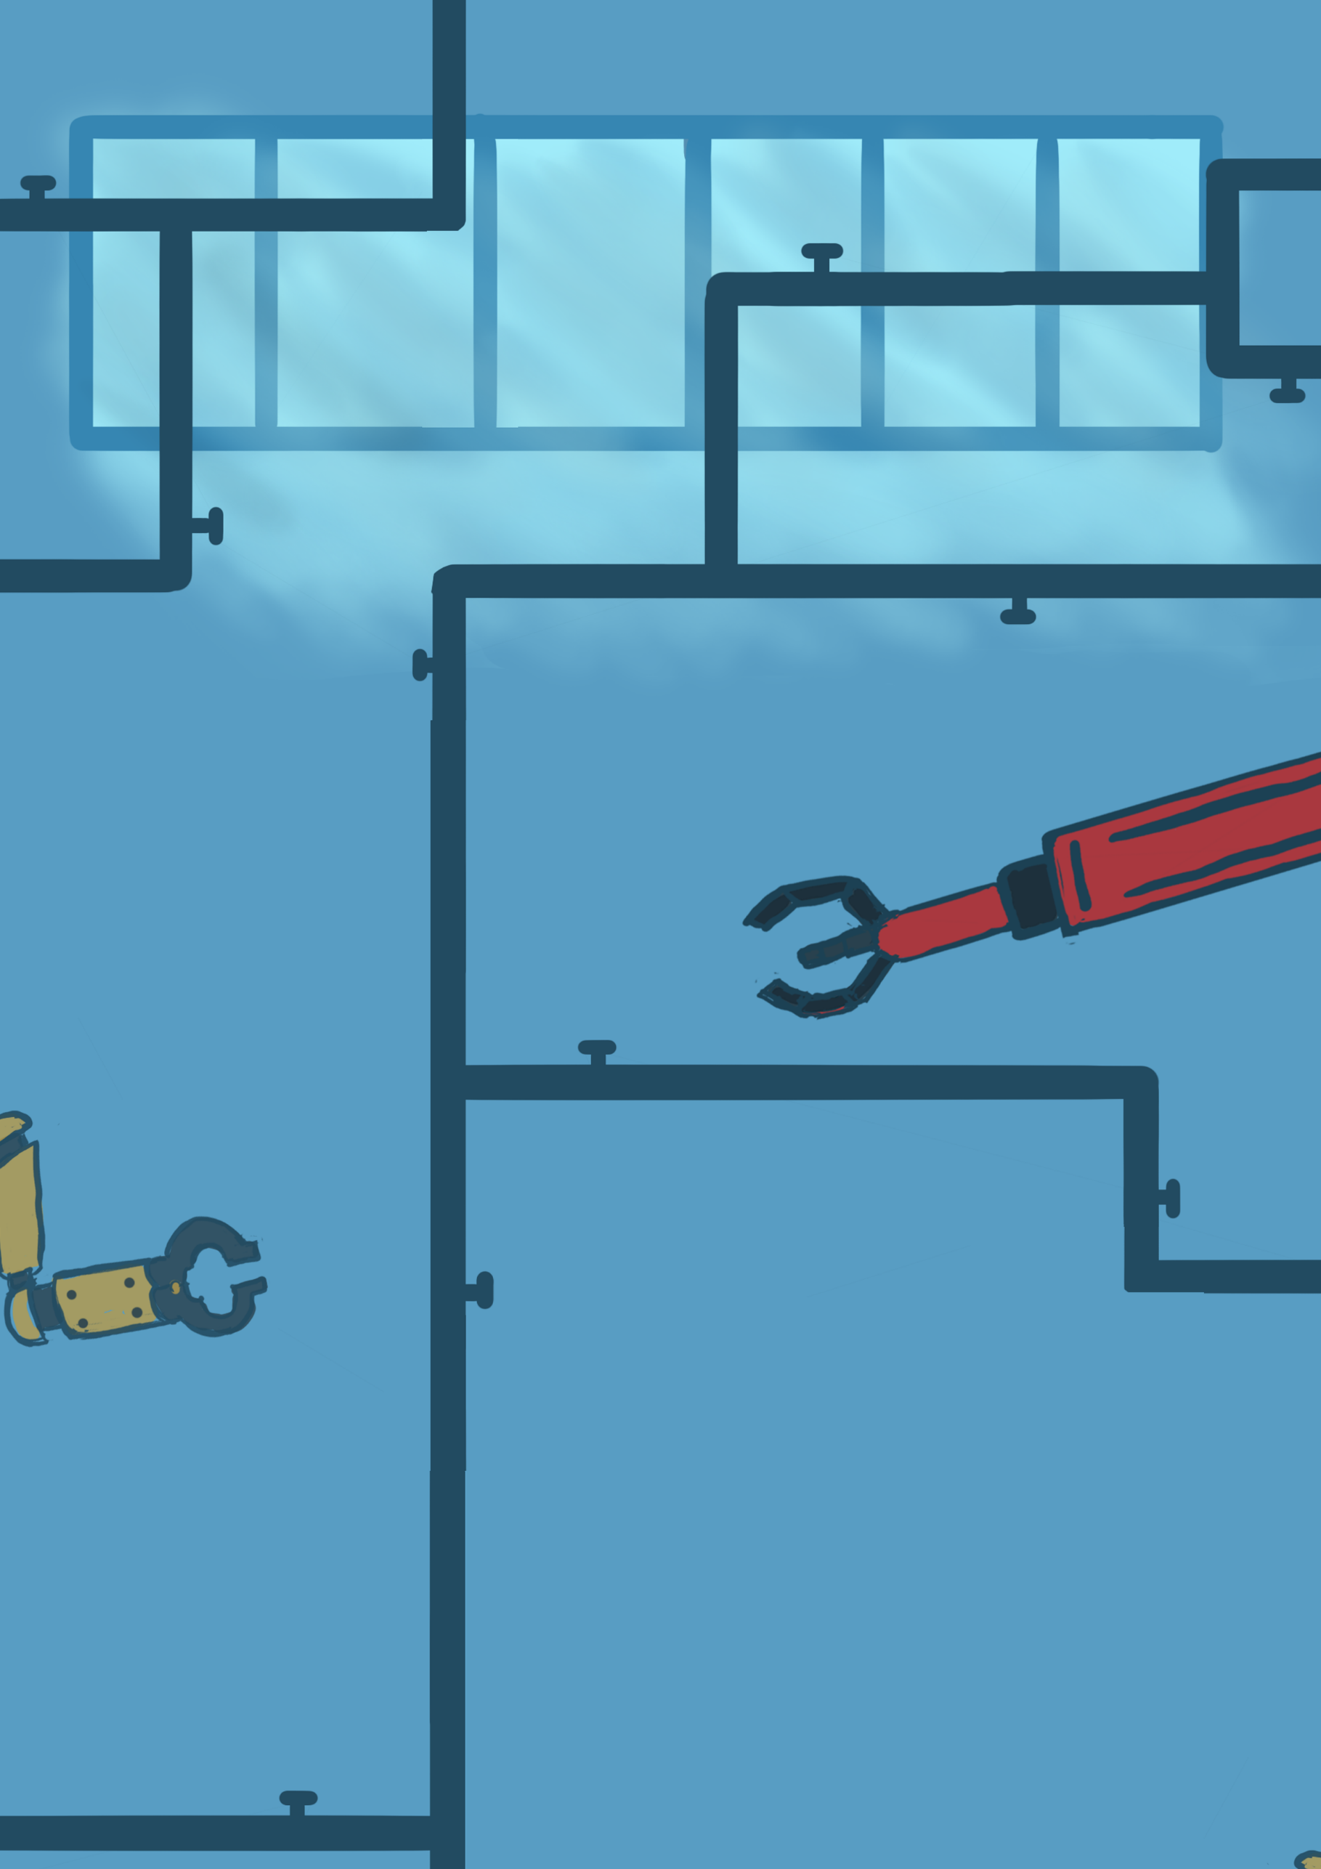

**Do you want to make a robot?**

**CMGT Final Approach**

Team members:

Humam Abud Allah - 428729  
Tamara Hooijmans - 461903  
Rob O’Connor - 445921  
Rick Oosthof – 421183  
Olivier de Haan - 112070  
Glyn Lyne – 445021

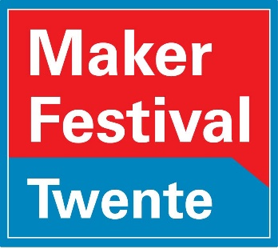Grading teachers:  
Rene Heijnen  
Remco Mikkers

Contents

Android Assembly Product 3

Merchandise 4

Testing 5

Processed Play Test Feedback 5

Other testing 6

Game Rules 7

Website 8

Trello board 9

Git 10

Individual Work 11

Individual Work Humam: Sound Designer/General Artist 11

Individual Work Tamara – 2D Artist 12

Individual Work Rob – Scrum Master/ 3D Artist 13

Individual Work Rick – Web/Game designer 14

Individual Work Olivier – Chain Reaction Designer 15

Individual Work Glyn – Programmer - Green Card 16

Teamwork reflection 17

Starting notes:

Green card goes to Glyn Leine for working really hard overall and making sure we still had something to show at the moment where it mattered most.

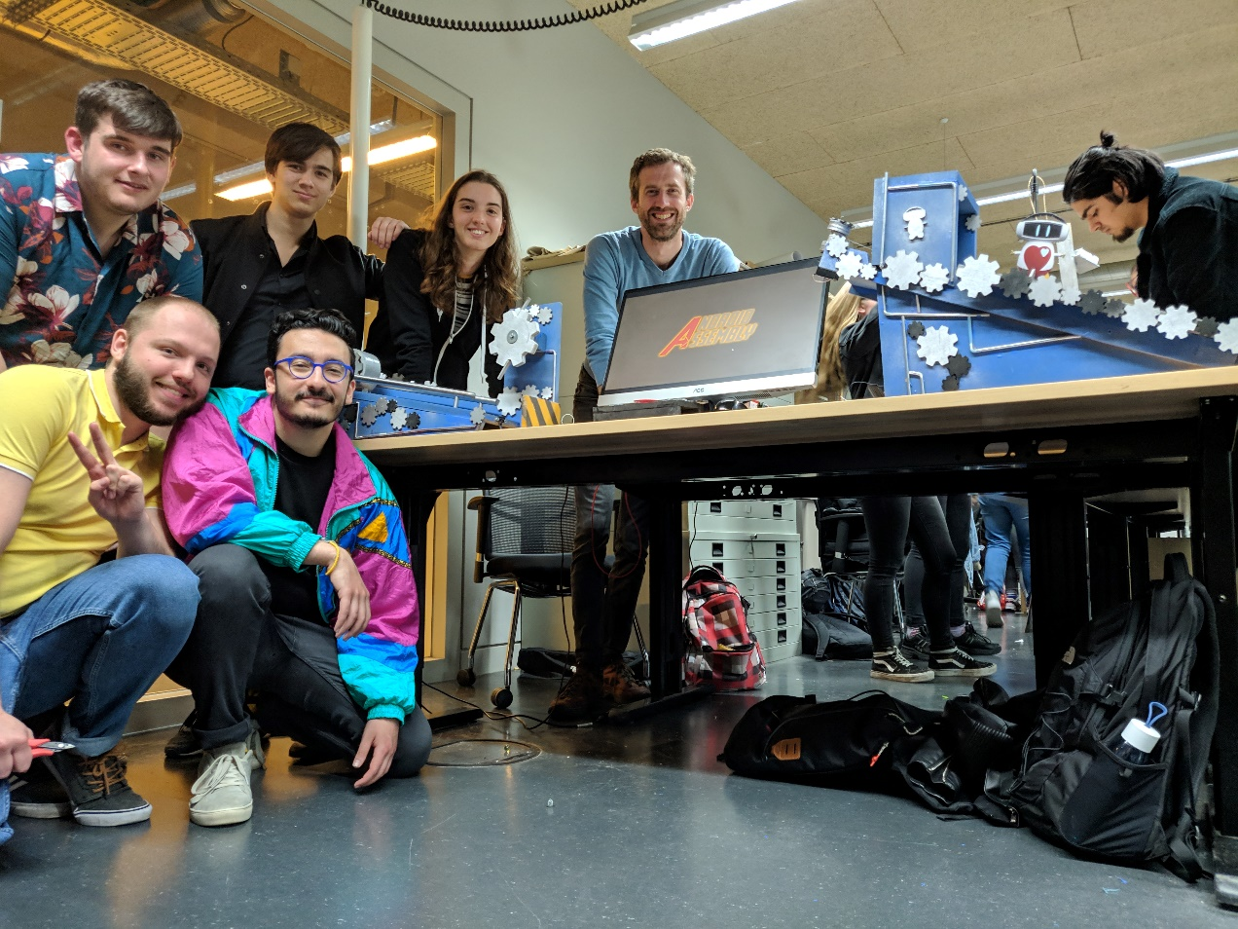

# Android Assembly Product

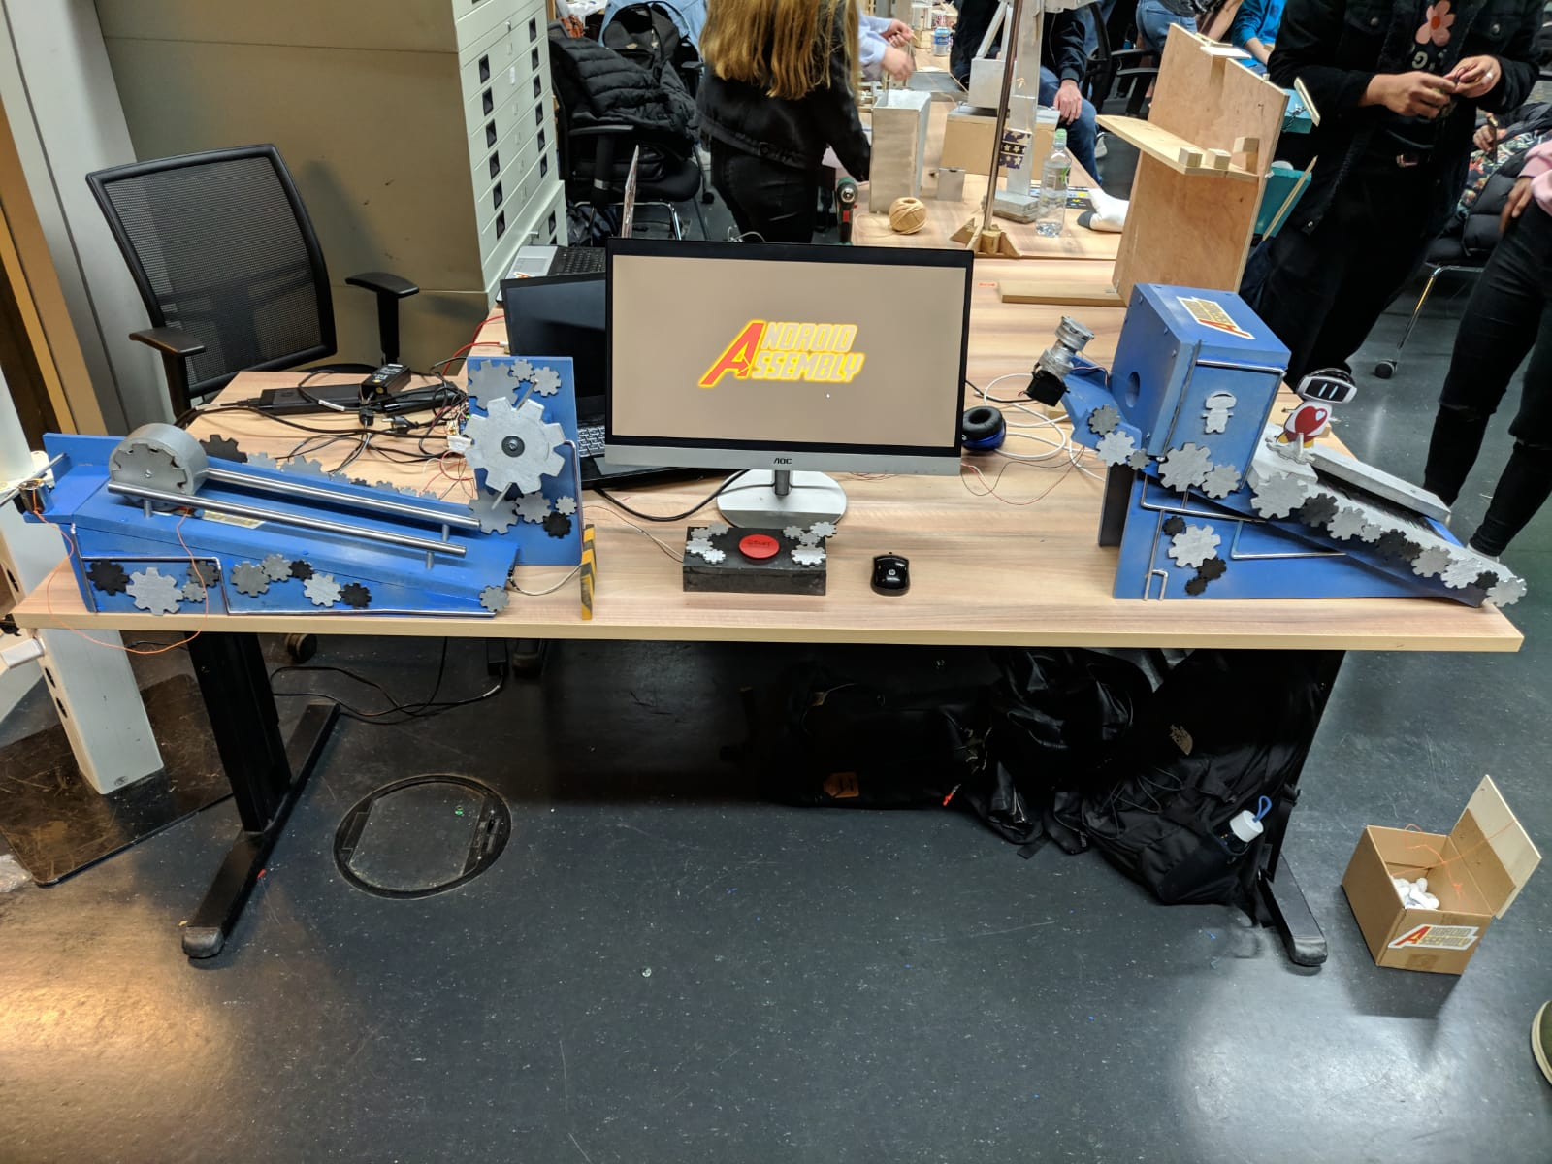

*[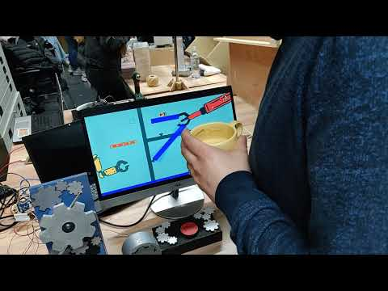](https://www.youtube.com/watch?v=L7TlSUYoAo0)*<https://youtu.be/L7TlSUYoAo0>

Sadly in all the commotion, the box had been moved back and forth and wasn’t properly aligned.

# Merchandise

There’s a total of 4 merchandise options, 1 concept (the hoodie) and 3 that were concepted and then fully realized. (Stickers, poster and keyhangers)

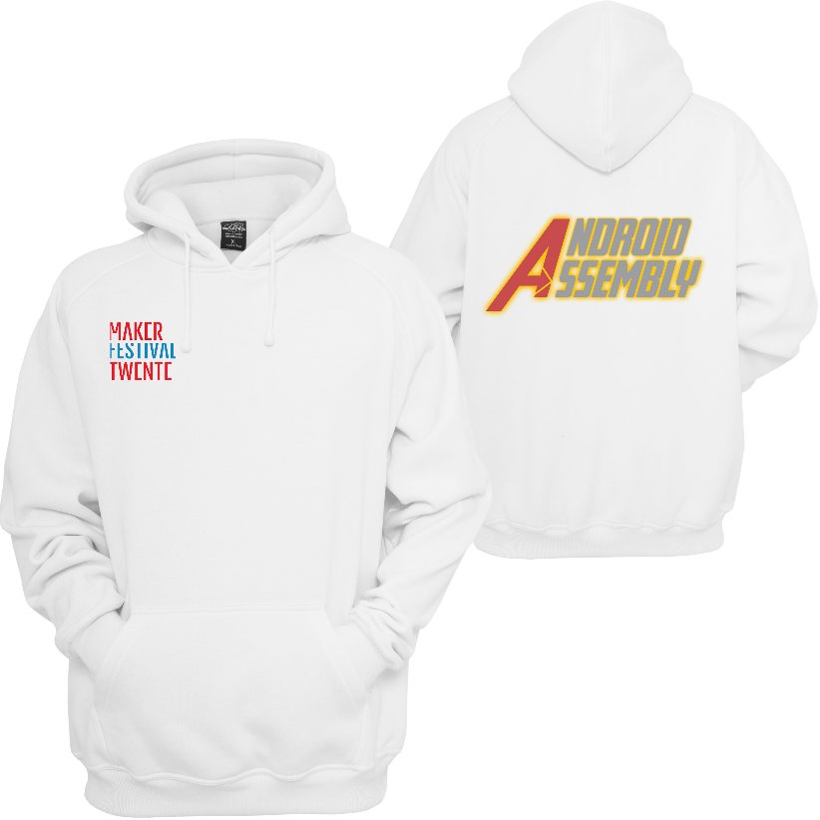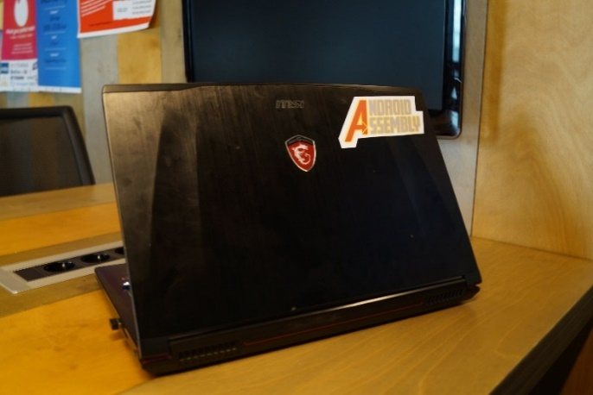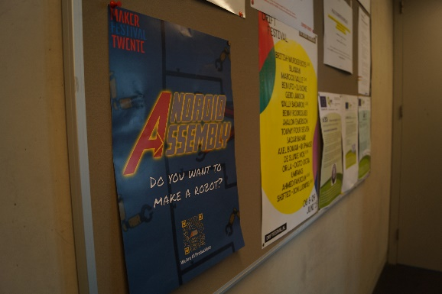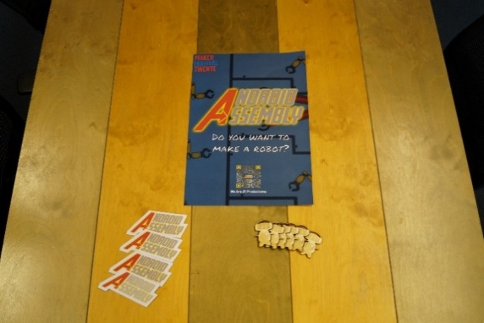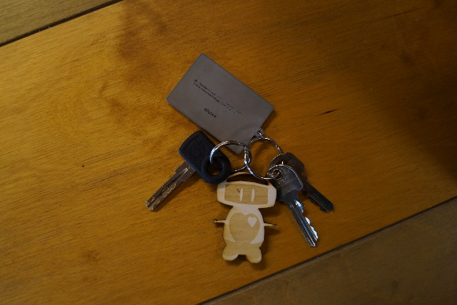

Testing

## Processed Play Test Feedback

We divided the play test feedback into two sections: Positive points and Discussion points, positive points are a nice pat on the shoulder to know we’re doing well but negative feedback/critique needs to be discussed. We then divided the feedback we got into feedback that was for the change and against the change, after this we had a discussion about it with concrete arguments(And examples/thoughts of what to do with the discussion point). At the end of this discussion we had a vote, which decided what we would do with the discussion point.

**Positive points:**

The concept fits really well together between GXP and the mechanical bit.  
Concept fits really well with the target audience.  
The robot is a really fun idea.  
The art style is really nice and fits well with the children  
The theme overall makes sense  
The simplicity really fits the younger audience  
Aligns with metropolis well  
Magnet vs Fan is a really nice dichotomy  
Really cool robot design

**Discussion points:**

|  |  |
| --- | --- |
| Failure State | |
| Feedback for | Feedback against |
| Without failure state it can get boring really quickly (Especially older kids) | No failure state is nice for younger kids who have no experience with the mouse/anything |
| Without failure state the kids don’t learn | The game is too short for the kids to notice there’s no failure state anyway |

Arguments in group discussion: Objective isn’t to learn game but learn real-world knowledge. We target the younger audience overall. More of a toy than a game. It’s impossible to appeal to the entire range of 4-12 with one game, thus our focus is mostly on the young. Younger kids can still play. Replay ability isn’t a factor in the design.

Conclusion: After the arguments we voted on the option of a failure state (automatic reset) or no failure state at all. We voted and got 5-1, we talked to the last person who wanted it to be fail able and presented our arguments and voting again after the result was 6-0 in favor.

|  |  |
| --- | --- |
| Art style too dim | |
| Feedback for | Feedback against |
| The art style has too much gray in it | Art style is really nice and simple and fits the children |
| The colors are very dim |  |

Arguments in group discussion: Assets are super colorful, so actually putting the assets on the backgrounds will make them pop and make this a non-argument. We changed the robot color from gray to a brighter white to see how that looked.

Conclusion: We really liked the brighter white robot version, so we changed to that, but kept the rest of the art unchanged.

|  |  |
| --- | --- |
| Longer chain reaction | |
| Feedback for | Feedback against |
| The chain reaction might be over so quickly they don’t notice it | People really liked the way it currently flows |

Arguments in group discussion: We disagree it’s too quick, with the max being 30 seconds we feel like our current ~20 seconds is already fine.  
Conclusion: No change.

## Other testing

In general, we did a lot of testing of the various products, our Trello was set up in a way where no task could be done without at least one other person looking at it. In the first week the artists extensively worked together and had a lot of voting on the art style and the development of it. The game idea went through several small iterations as well. We found it very important to have a gray box relatively early on, so we could see if all the mechanics were working and if the game design we had at the end of the week was feasible. The entire chain reaction was tested several times and in parts. Each interaction was tested individually before putting it together and testing it mechanically. Then the Arduino came in and via the Arduino code (we had two buttons and two servos’, so we just coded the buttons to activate the servo’s) we also tested if the electrical components worked together well. This led to a few hiccups and a lot of soldering, as we’d discovered by Wednesday that there’d be a few problems but thanks to this early testing everything was solved and done by Thursday evening in relation to the electronics. But, with all the merchandise, art and the chain reaction extensively tested there’s one thing that we were simply too late with.

This was the gameplay testing, we’d tested the physics very early on and made sure all the mechanics in the game were feasible at a very early stage, but we’d lost track of actually making sure the tiled map was working(Especially since we still had our tiled parser from last project). So, when it came to it on Friday, actually trying to import the Tiled map with the tiled reader there was a bug that ended up being too hard to fix/see under the stress of having to present in ~30 minutes which made our game a lot less presentable than we would’ve liked.

# Game Rules

When the game starts, the robot will be in a safe position where none of the physics are affecting them. The player can drag objects into the snap positions. There’s only two interactable objects, which are the fan and the magnet, and he can drag those into the sockets.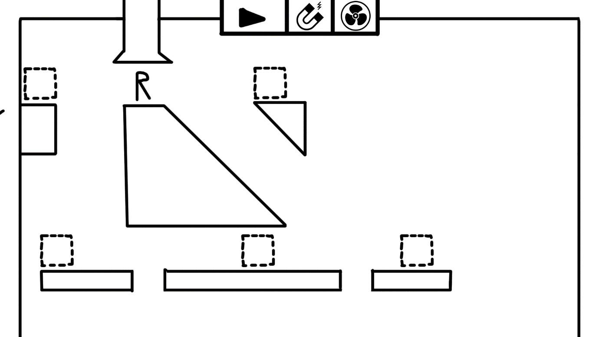

Early sketches of the game mechanics.

Objects will snap into the sockets, to make it clear where they’re supposed to go. The **fan** object pushes the player away from it and the **magnet** object pulls the player towards it. Usually, these objects will have a hole between the player and the object through which the player will **fall**, because **gravity is stronger than the pull of the objects**. In case the player places a magnet and a fan opposite of each other, **the magnet takes priority over the fan.**There’s two objects which can’t be placed by the players, these are the **wall** which is a simple collision object that the player either stands on or collides with and the **conveyor belts** which move the player in a set direction. There is also the rotatory status, which means any object that can be placed can also be made to rotate in a certain direction and at a certain speed.

The idea of fake choice is important in the game design, all the player is doing is just putting the fan or the magnet down. No matter which one they do, it will always cause progress and lead the player to the end of the level. The only way to ‘fail’ is to not do anything, doing any of the actions the game allows will lead to victory.

Also check the video of the chain reaction to see this in action.

Website

Links:

<https://tinyurl.com/androidassembly>

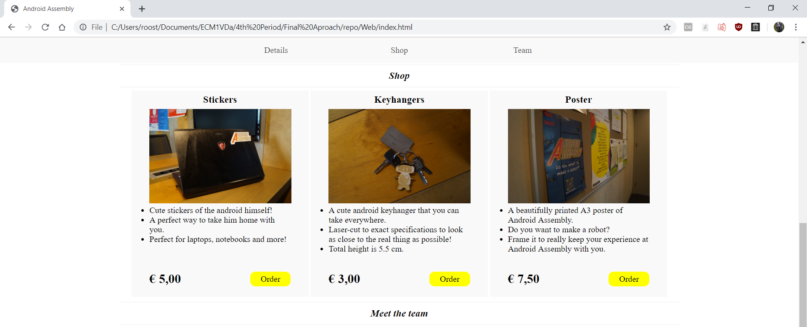

Android Assembly website is hosted via google drive and then drive to web. For the style I wanted something clean and professional. The font itself was the more serious font we used in the infographic as well. Written entirely in HTML5 and CSS it uses mostly custom div classes for the main structure except for the nav bar. Both header and article are extensively used within the custom divs to clearly mark what content is being presented when. It’s a one-page website with 3 sections. The structure of the document itself is divided as following: Landingpage, nav, description, shop, teamdisplay.

Landingpage is the image/video on the background and the logo, the first thing people see when they enter the site. I say image/video because we’ve tried both and there’s CSS and HTML for both. The first image is positioned relative in a div, with the logo in a new div and position absolute within it so it will always cover whatever content is within the landingpage. The nav is a sticky navigation bar that moves down with the user. The description is a few more pictures to look at as well as a nice description made to interest people for the chain reaction.

Shop is self-explanatory, with the 3 items of merch we’ve worked out all on there. It uses a div for the shop windows which has a position-relative and a set height/width, whilst the price/buy button are in a position absolute div and position from the bottom. The <br> below the text in each shop window is for mobile, as the height on mobile is set by how long the text is (Since they’ll be under each other, they don’t need to all be the same height) so there needs to be at least one line of blank space for the price/buy button to go.

The teamdisplay works much the same as shop, just simpler as it is only one image and some text. On the bottom of the nav, the description and the shop are empty <h2> tags with the id of the page below them that have been hidden (In hindsight these should’ve probably been divs, but they were originally titles and I repurposed them). This is so that when you press the nav buttons and it takes you to the ID, the actual nav bar won’t cover the content you’re viewing by linking to slightly above the page instead.

# Trello board

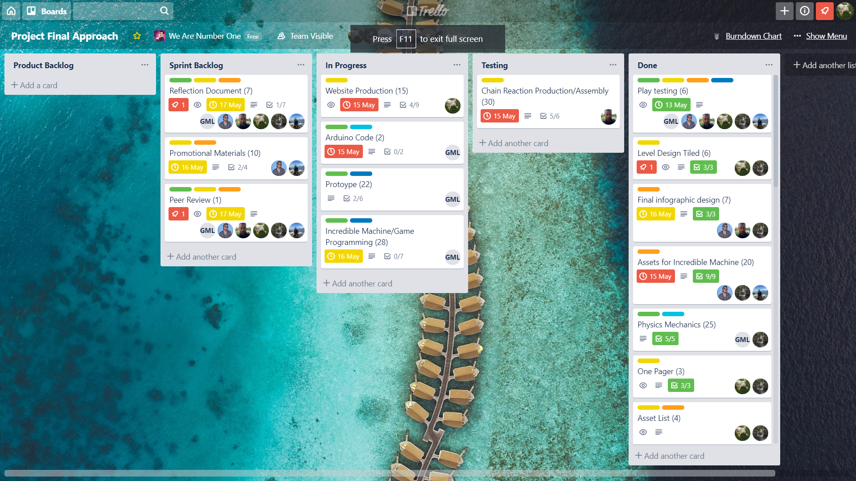

<https://trello.com/invite/wearenumberone4/6a9767914bb138a1269ef6d43971dead>

Trello explanation:

Here are our Trello board and burndown chart, as you can see the burndown chart is pretty steady until about the 15th of May where we finished a lot of story points but we’re pretty happy with how the flow of work went over the two weeks. Most of the finished story points on the 15th of may had been worked on before, but the 15th of may had a lot of finishing up work.

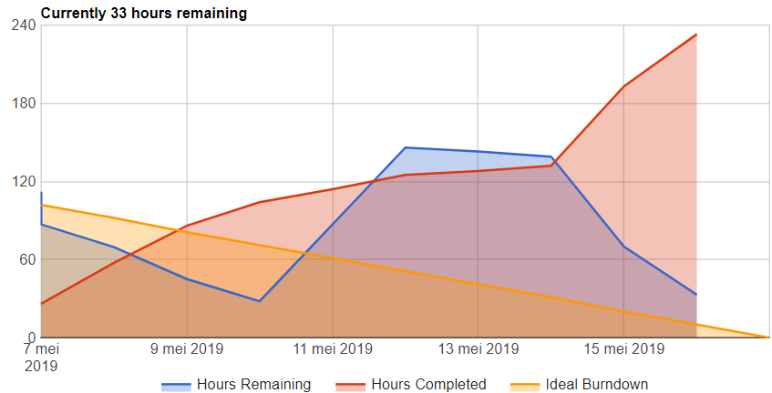

On the Trello there’s roles; Artist, Designer, Programmer and for the programming tasks it’s split up into engine development and gameplay programming. Each task has a role and programming ones have a role and a description. Each task has a user story and a check list which needs to be worked through and when those are completed those are the grounds of completion.

Each task also has one or more people on it, depending on who’s supposed to work on it. When it goes to testing, the tester also puts their name on it so that when something is wrong there is full accountability.

The Trello structure goes as follows: Product backlog, Sprint backlog, In Progress, Testing, done.  
Everything for the project is in the product backlog. Things that are to be done in the current sprint go to the sprint backlog. When someone is currently working on it, it goes to in progress. Then when the checklist is complete it goes to testing. Once it is approved by the tester it goes to done. At the end of the day all tasks that are in progress should be moved back to the sprint backlog and story points spent should be logged on the burndown chart.

# Git

We used GitHub and SourceTree to create a private repository where we shared all of our files. The occasional preview for testing/quick opinions might get shared via discord but every single file we made is findable in our repository as well as all the various iterations of each file.

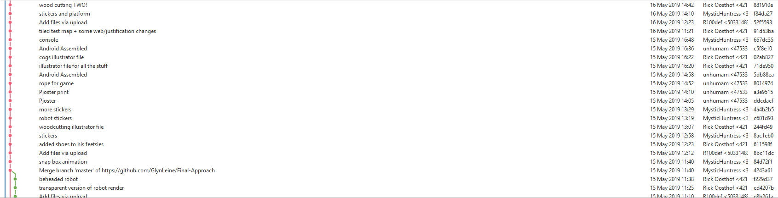

Descriptions were short and to the point, but for the vast majority descriptive of what they were and what had changed. The occasional joke might be in there but they all made it clear what was uploaded and trying to find an older version of a file in SourceTree was never actually difficult.

The main branch was our programmer’s branch, and due to the fact that he didn’t need to pull the 4th new t-shirt design every single time his branch would often be behind, which would cause these side branches from his later branch merge.

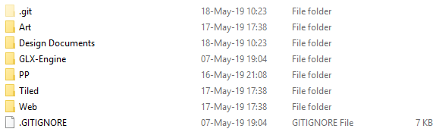

The file structure itself of the repo was solid and worked, with folders being set up as was needed. Everything had a clear place on where it should go.

# Individual Work

## Individual Work Humam: Sound Designer/General Artist

I spent most of my time creating an auditory experience so it enhances the feel of the project by having music and audio effects that are in tandem with the visuals. There are sound effects that will play simultaneously with the chain reaction. I have also made the initial sketches of the character and most of the objects used in the digital part, so mostly all the 2D elements. I have also worked with Tamara and Rob to agree on the final sketch of the robot, so it was a collaboration of all artists. Other than that, I also created the logo of our installation, designed and created the info-graphic with all the content, alongside the poster itself. I made the infographic with circular layouts because circles appeal more to children and are friendlier. I have added a short description of each step of “making the robot” that is not too obvious nor too vague. The intention was that the info-graphic creates an image in the head of the person reading that prompts him to press the button and find out how the experience will play out.

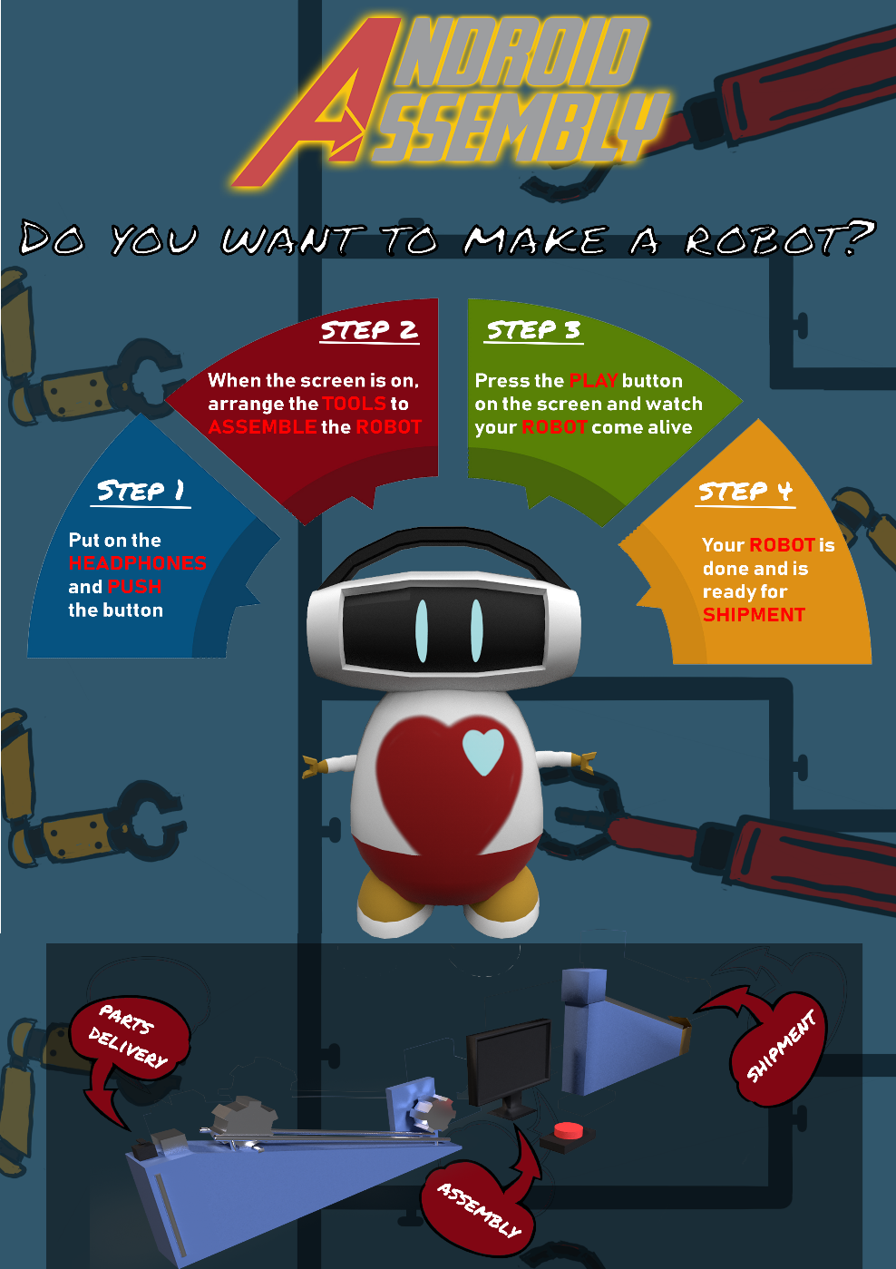**Full list of things I did:**

* All the audio
* Character sketches
* Concept art
* 2d objects
* Logo
* Infographic
* Poster

## Individual Work Tamara – 2D Artist

In the project I did most of the 2D art. For example, I made sketches and concept art for the robot. I gave these to Rob, so he could 3D model the robot. I also made all the 2D animations, which was very challenging since I haven’t done 2D animation before. I ran into some problems but Rob and some teachers were able to help me out a bit. In the end I think animating went pretty well, even though I had no experience before. Next to the animations and the robot, I made the stylesheet and the mood board. I had some troubles with the mood board since it looked more like a collage than a mood board. Eventually I focused on the concept art and Rob made the final mood board. I made different backgrounds that fit perfectly underneath each other which makes it easy to adjust the order of the backgrounds in the game.

Communication went very well between me and the other teammates, when I ran into troubles I told them and they helped me out, it was the same the other way around. I also helped making the promotional material, I made the layout for the sticker sheets and cut them out. I made some designs for t-shirts and sweaters. Next to all this I helped a bit here and there.

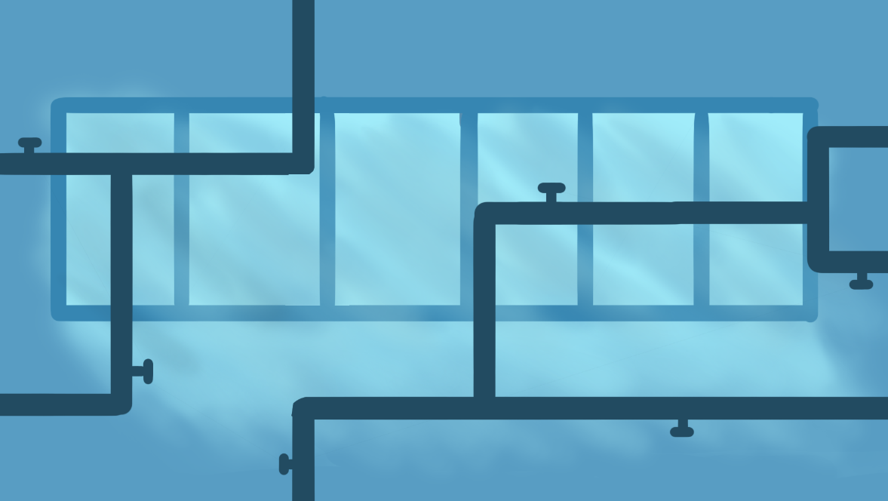

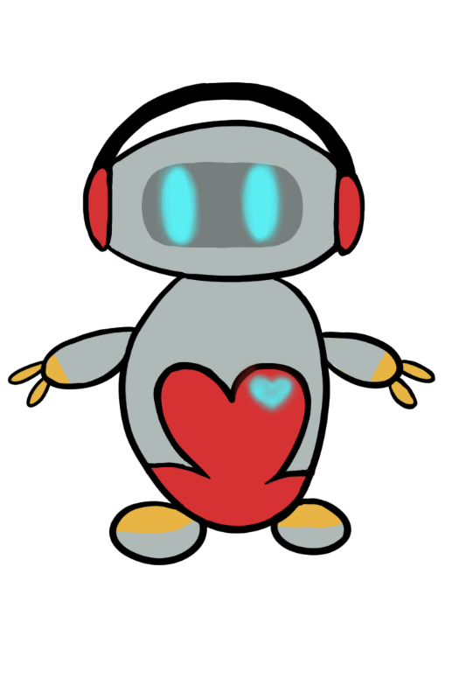

**Full list of things I did:**

* Stylesheet
* Mood board
* Concept art
* 2D animations
* Backgrounds
* Promotional elements

## Individual Work Rob – Scrum Master/ 3D Artist

My primary focus over the 2 weeks were 3d modelling (The main character and a render of the chain reaction) and Scrum Master/Project Management. I enjoy scrum a lot and I volunteered at the beginning to be scrum master, as you can see from the Trello section of this document my system is fairly standard but it works very effectively, in my opinion means the planning went very well. Some of the things that I think I could do better as a scrum master for the next project is put more pressure on people to log there used story points on the burndown chart to make that more accurate.



My other role as an artist I also feel went quite well, at the start I focused on stuff like figuring out the general style of the game with Humam and Tamara, and then I made the mood board, which was a challenge as it had 4 different iterations before it was good enough. Then my primary focus was 3D modelling the main character which we intended to 3D print, I successfully modeled and textured the character however, I left it too late to prepare the model for print, which is a lesson I learned and will know in the future. I also was the primary tester for a lot of the user stories on this project because I had a very good overview of the tasks.

**Full list of things I did:**

* Character Model
* Incredible Machine Model
* General Assistance
* Project Management
* Mood Board
* Testing

## Individual Work Rick – Web/Game designer

Initially, my focus was mostly on the game design, the documents (such as the one pager) and the website. I made the PowerPoints as well. This, along with the initial website design covered my first week pretty nicely. By Monday most of the website was done with only content and some small style changes here and there based on feedback left. I covered and processed the playtest here as well and made a template for this document. I started concepting some basic level design as well as making the various illustrator files for the laser-cutting (such as the keychain or the cogs on our physical chain reaction).

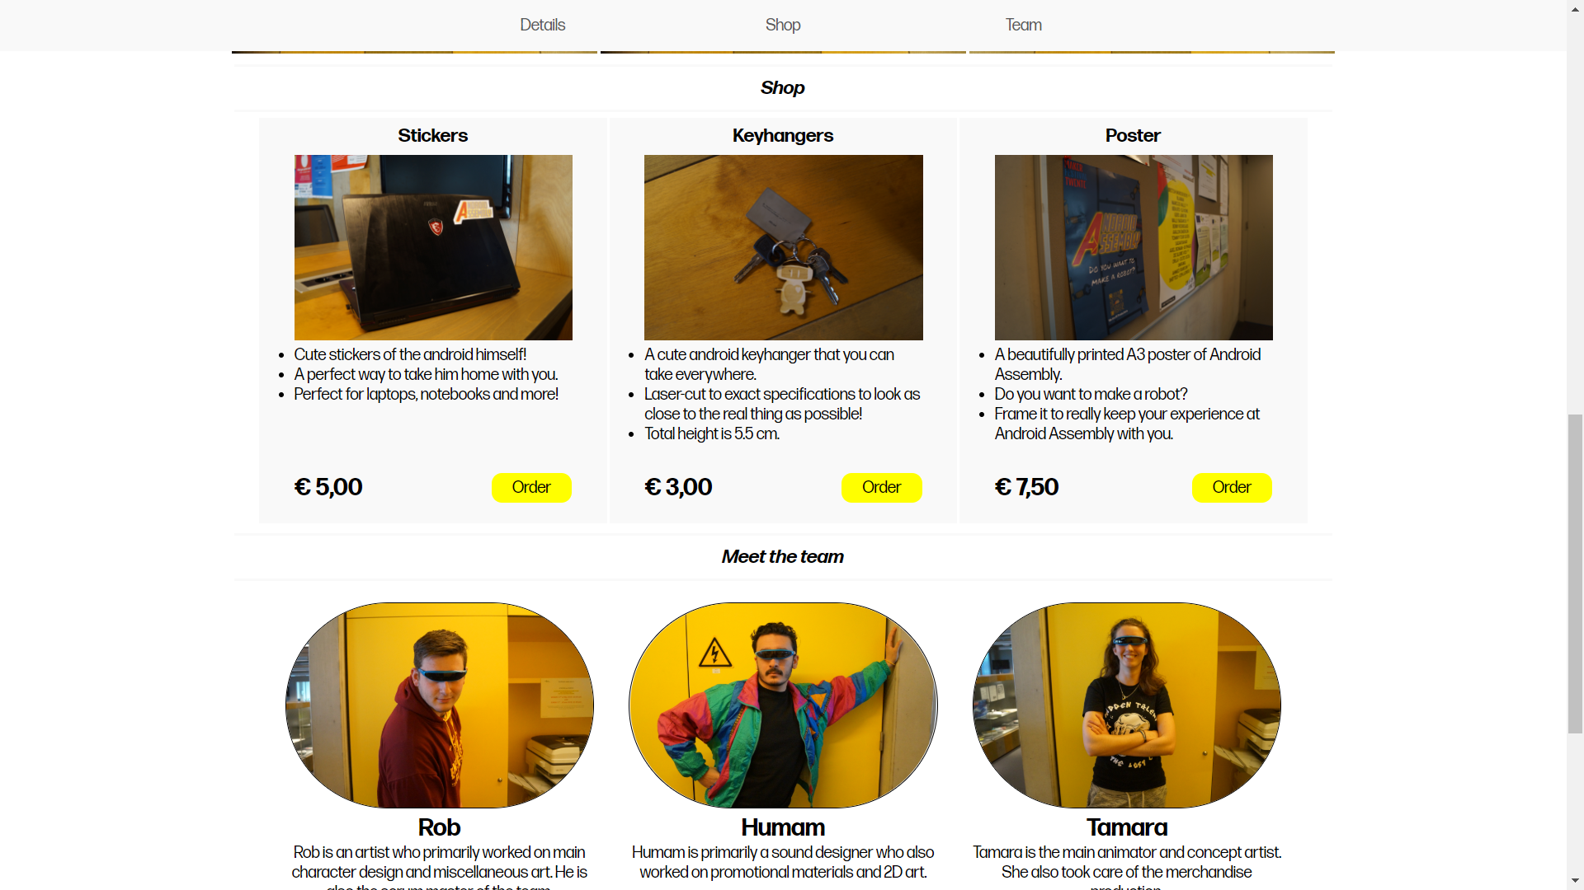

I did a few art odd-jobs as well, such as cutting out the limbs of the robot in photoshop. At this point (Wednesday, week 2) I was also asked to help with the wiring, as we’d done little to this point except breadboard a few buttons. We have two servo’s and two buttons, and I tested and soldered them all (With a little help from Olivier when I had to go back to level design) and managed to get it all working. Lastly, I also finished up the level design. Both the tiled maps that didn’t make it as well as the actual final design that we hard-coded in.

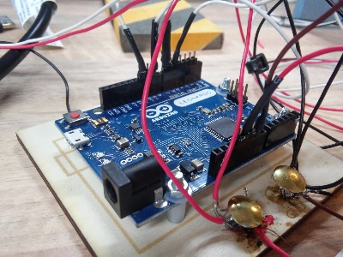

**Full list of things I did:**

* Game design document
* One pager
* PowerPoints
* Play Test
* Website
* Arduino Wiring
* Level Design

## Individual Work Olivier – Chain Reaction Designer

I researched chain reaction online and started brainstorming with my team to see if our vision aligned. I also helped here with the initial documents and deciding what direction we’d be going with the design. I then made an inventory list of items I would like to use and bounced those ideas of my team and made a selection of items. I made a rough draft of my vision and added sensor and actuator locations on it, with this in mind I made a complete layout and storyboard.

I gathered up the parts and started testing the various ideas we had. There were plenty of unsuccessful or unreliable mechanics interactions but thanks to the early and constant testing we ended up with a very stable chain reaction.

My team was a big help in advice and comments during this part, everything was discussed and I could just keep working without second guessing my actions. In the end I teamed up with Rick to add the electronics, he did all the wiring and test coding, and I then added the parts to the machine.

After everything was completed my team and I decorated it with items designed and produced by the artists and painted the whole machine together.

**Full list of things I did:**

* Concepting for Android Assembly in general
* The concepting for the chain reaction
* Finding the parts for the chain reaction
* Testing the chain reaction
* Polishing the chain reaction



## Individual Work Glyn – Programmer - Green Card

My task as the programmer of the team was to build a functional physics engine to build our physics-based interaction on and to build the interaction itself. Initially I planned on finishing the ECS based engine design I was building before the start of the project. It would’ve been great to build the interaction in since it was built with a verlet-integration based physics engine in mind. However, after day 1 it became apparent that the design was too complicated to get finished in time, even with most of it already finished before the project started, that besides that the design was way overkill. So instead, I decided to scrap it all and go with a way simpler design based on the old original collision handling system in GXP. Using a simple designated EasyDraw object in the game class as a UI/Debug info object I started working on a new physics engine (the two separate designs are shown below).

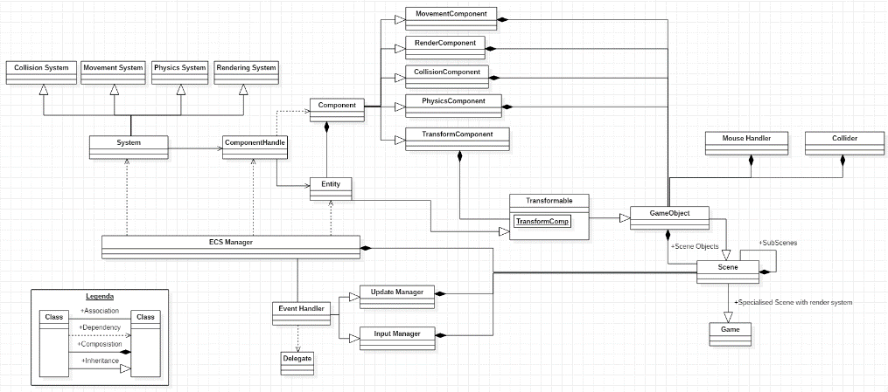

Initial Engine Changes

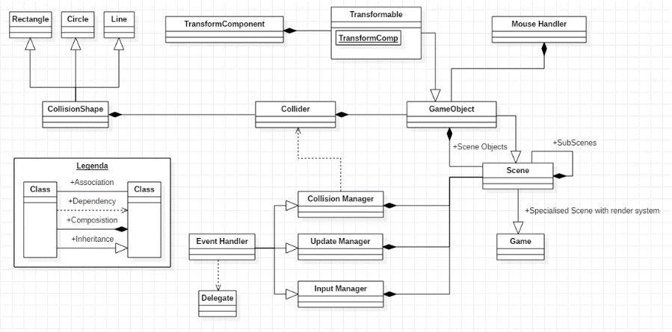

Eventual Engine Changes

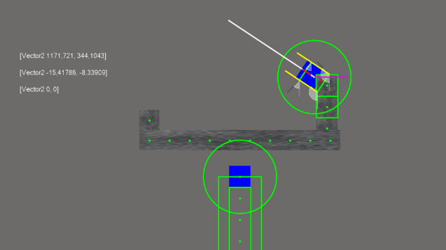

Of course, I ran into plenty of bugs, however by visualising as much data as possible through the EasyDraw object most bugs were easily fixed. However, the as almost per usual with me not everything can go smoothly. I neglected to look at my Arduino code and the tiled parser since I was convinced that they shouldn’t have formed an issue. The Arduino code was finished easily within less than an hour of work, and the tiled parser should have taken just as little time. However, the tiled parser brought another major bug to light I had not seen coming, mis alignment between object components. Textures, colliders and the containing objects were misaligned when created procedurally. After having thrown the parser out of the window and hand placing all the objects instead it became apparent to me that my tunnel vision had made me overlook a simple detail that was fixed within mere minutes. However, by then it was too late, and it was time to present. We were still able to present a decent interaction; however, I would’ve liked it to be more. Besides all my team still decided to award me the green card due to how much work I had poured into getting everything working.

**Full list of things I did:**

* Revamp collision detection system
* Implement base physics system
* Build support for kinematics, attraction and repulsion, linear and angular physics
* Build gameplay objects
* Build Arduino software and engine communication systems
* Build and test gameplay

# Teamwork reflection

**What were the challenges/problems you faced as a team and how did you face them?**

During the feedback processing we had a conflict where the engineer disagreed with the decision to not implement a failure state. We had a vote and it was 5-1, so we discussed it with him and let him explain his reasoning to us after which we explained our reasoning to him to see if we could sway him. Holding a second vote afterwards led to a 6-0 result.

We also had a problem with deciding who from our team deserves the green card, we all felt everyone deserved it, so initially we resolved to give it to the person who had the highest score. We had another challenge, however, in that the tiled parser was not working properly in time and we’d started testing it too late. Before the start of the chain reaction we still weren’t done. Instead, we decided to roll back the game to an earlier state and hard-code the level in instead, so we could still have our interaction and our physics. This was mostly Glyn’s task and although the team helped him in the best way they could, by having all the assets ready or by having the coordinates for the objects in the hard-coded level ready, the heavy work and the stress were carried by him there. This is also why we decided to give the green card to Glyn in the end.

**What were the roles and were the roles respected?**

At the beginning we defined our roles very clearly before we even had a concept. Glyn would be our GXP programmer, Rick would be our web developer and Game Designer, Olivier would be our chain reaction designer and producer, Tamara would be our 2D animator, Rob would be our 3D artist and Scrum Master and Humam would be our 2D artist and Sound Designer.

We respected everyone’s roles by stating clearly at the start that everyone (within reason) could decide about their task, we also came with a positive attitude every day and gave constructive feedback instead of just saying something like “make it better”, we gave some feedback as to how to make it better.

**In what ways did you manage to help each other outside of your roles?**

The biggest way we helped each other outside of each other’s roles was voting on all big decisions made about the direction the project. This gave the team a democratic feel and made production go very smoothly. We also did a daily stand up where each person said what they did the previous day, what they plan to do today and raise any issues they have.

On the last day all artwork had been finished, so the artists were all hands-on deck to help Olivier finish the production of the chain reaction.

**What would you change for next project?**

Earlier game tests/Earlier playable prototypes